2017
Design and Creating a Basic 2D Game
Assignment 1
Shaun Mifsud 4.2B

Question 1
- Unity and Unreal engine are both game engines used to build and structure the game. (Anon., n.d.) One of the advantages of unity is that it is based on C# which is a high level computing langauge which makes it easy to develop. (Singh, 2016) Another advantage. Unity has its own assets store where developers can use premade objects such as 3D or 2D models, sounds and visual effects in their game without the need of spending time and resources to create them themselfs. (Singh, n.d.) Developing 2D games are easer to create in Unity since the structure of unity and the UI makes it easy for a beginner to do so. Since unity is more popular among programmers it has the benefit of having different types of interections with other developers with the use of social media,fourms and other types of community that might assets in the creation of the game. (Singh, n.d.)
- Two of the programming language are C# and C++ which are both used in game engines. C# is much easier than C++ which makes it easy for developers which are starting out to develop games. C# is also feature rich. C# has large libraries which are a set of code that can be used and implemented into the code therefore makes it faster for the developer to program certian functions. (Lear, 2012)

Question 2
a)

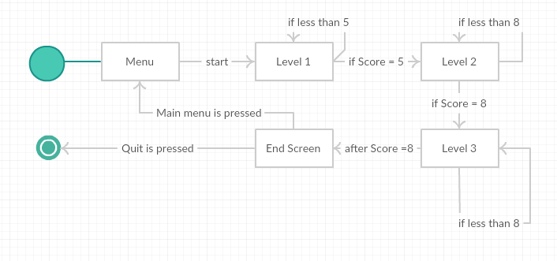

b)
Question 3
Compression is when information on a storage medium is compressed to make the file size smaller. One of its advantages is that it allows more information to be stored on the same storage device. When developing a game especially when the game is resource demanding the size of the game can be large due, that high resolution images, sounds and other types of media requires large amount of data in-order to maintain the information. If the game is too large, mobile devices may not have the sufficient storage capacity needed since these devices have limited capacity to store the game and are limited on the amount the store can be expended if at all. Compression can also be beneficial since it increases performance which makes it more efficient. (Anon., 2017) For example assets which are not the main focus of the game are better to compressed because they are not important.

Image above shows the different in quality between raw (uncompressed) to JPEG (compressed).

References
Anon., 2017. Intel. [Online]
Available at: https://www.intel.com/content/www/us/en/support/articles/000006354/memory-and-storage.html
[Accessed Novmber 2017].
Anon., n.d. potenza. [Online]
Available at: http://www.potenzaglobalsolutions.com/blogs/5-rarely-known-advantages-and-disadvantages-of-unity-game-development
[Accessed November 2017].
Anon., n.d. teradata. [Online]
Available at: https://www.info.teradata.com/HTMLPubs/DB_TTU_16_00/index.html#page/Database_Management/B035-1093-160K/rao1472240581575.html
[Accessed November 2017].
Singh, A., 2016. Quora. [Online]
Available at: https://www.quora.com/I-am-learning-game-development-on-Unity-3D-How-is-Unity-3D-as-a-platform-for-game-development-What-are-its-major-advantages-and-disadvantages
[Accessed November 2017].
Singh, A., n.d. Quora. [Online]
Available at: https://www.quora.com/I-am-learning-game-development-on-Unity-3D-How-is-Unity-3D-as-a-platform-for-game-development-What-are-its-major-advantages-and-disadvantages
[Accessed November 2017].

